WxMonitoring Installation Guide v0.1

# Introduction:

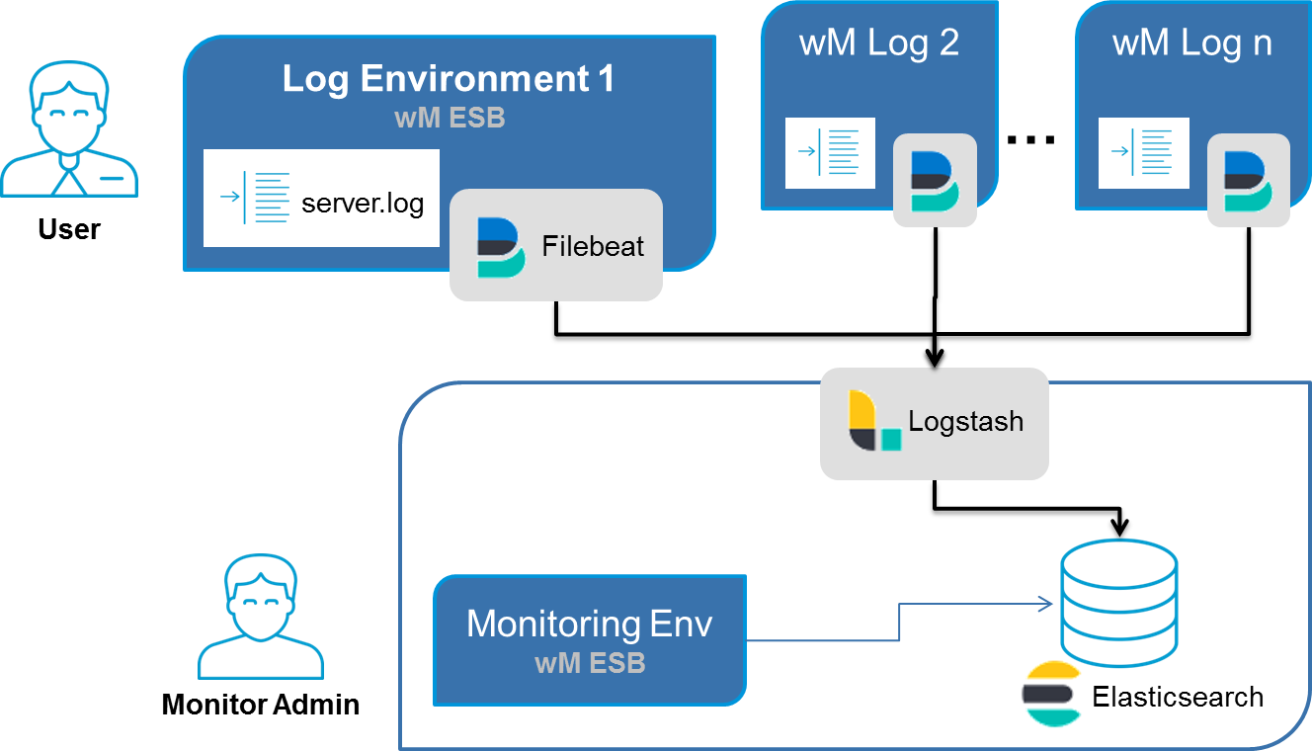

In this document “Log Environment“ refers to your webMethods environment that contain logs that are to be monitored. “Monitoring Environment” refers to a separate environment which will run WxMonitoring.

For simplification both log and monitoring environment can be installed on the same webMethods installation (e.g. in development). It is recommended to use separate monitoring environment for your Test/QA and Production stages.

WxMonitoring has been developed and tested with 9.10. It should work with webMethods 9.10+.

# Prerequisite:

WxMonitoring requires the installation of the following products

* Filebeat (at least version: 6.2.2) is installed on “*Log Environment”* server. (Filebeat installation guide : <https://www.elastic.co/guide/en/beats/filebeat/current/filebeat-installation.html>)
* Logstash (version: 6.2.2) is installed on “*Monitoring Environment*”. (Logstash installation guide : <https://www.elastic.co/guide/en/logstash/current/installing-logstash.html>)
* Elasticsearch / Monitoring Environment (Setting up ElasticSearch : <https://www.elastic.co/guide/en/elasticsearch/reference/current/_installation.html>)
* webMethods 9.10+ Integration Server / all concerned Log Environments, and Monitoring Environment

Download WxMonitoring from Labcase <https://labcase.softwareag.com/projects/wxmonitoring> or TechCommunity

# Getting started

## Monitoring Environment

1. Start Elasticsearch server
   1. e.g. run %ES_HOME%/bin/elasticsearch.bat
2. Start Integration Server
   1. e.g. run %SAG_HOME%/profiles/IS_default/bin/startup.bat
3. Install IS package WxMonitoring
4. Test installation
   1. Open <http://localhost:5555/WxMonitoring/>  
      You should see an empty search result page
   2. Open <http://localhost:9200/_cat/indices?v>

You should see indexes wxmonitoring-processes, wxmonitoring-events-original, wxmonitoring-events-xxxx.xx.xx, wxmonitoring-event-rules

1. Start Logstash
   1. The following instruction describes how to start Logstash from command line. Please see below instructions how to start as a service (recommended in test/qa and prod environments)
   2. Navigate to “…\packages\BG_Monitoring\pub\elk\logstash” directory
   3. Edit file “startLogstash.cmd” and update correct paths for following variables
      1. SAG_HOME: path for software ag home folder (e.g. c:\softwareag)
      2. LOGSTASH_HOME: path to logstash home folder (for e.g. C:\SoftwareAG\logstash-6.2.2).
      3. LOGSTASH_PORT: “5044” (default port - only change if needed).
      4. ELASTIC_SEARCH_ADDRESS: “localhost:9200” (default address - only change if needed)
   4. Run “startLogstash.cmd”.
   5. Before proceeding, please verify logstash has successfully started by navigating to logstash logs (%LOGSTASH_HOME%/logs/logstash-plain) and verify following log has been recorded:   
      “[INFO ][org.logstash.beats.Server] Starting server on port: 5044”

## Log Environment

1. (opt.) Copy following files from WxMonitoring\pub\elk\filebeat to anywhere in log environment server.
   1. startFilebeat.cmd
   2. wxmonitoring_filebeat.yml
   3. install-wxmonitoring-filebeat-service.ps1
2. Starting Filebeat
   1. The following instruction describes how to start Filebeat from command line. Please see below instructions how to start as a service (recommended in test/qa and prod environments)
   2. Edit file “startFilebeat.cmd” and update correct paths for following variables
      1. SAG_HOME: path for software ag home folder (e.g. c:\softwareag)
      2. FILEBEAT_HOME: write path to filebeat home folder   
         (e.g. C:\SoftwareAG910\filebeat-6.2.2)
      3. SERVER_ID: write name of this log environment (should be same as provided in the monitoring environment global variable MONITORED_SERVER_LIST, e.g. dev1)
      4. LOGSTASH_HOST: address URL of Logstash on monitoring environment   
         (e.g. 127.0.0.1 or localhost).
      5. LOGSTASH_PORT: verify logstash port is correct (e.g. 5044).
      6. LOGFILE_PATH= write path of the log file that is to be monitored   
         (e.g. C:\LOG_COLLECTION\sample_process_server.log).
   3. Run “startFilebeat.cmd

## Test Installation

1. Navigate to IS_Server_base_url/wxmonitoring from browser and verify logs availability.
2. Test Elastic Search <http://localhost:9200/_cat/indices?v>
3. See log files for Filebeat / LogStash

## Appendix: Install services

1. Start Logstash as a service:
   1. Download nssm (https://nssm.cc/download)
   2. Navigate to “default\packages\WxMonitoring\pub\elk” directory. Edit file “install-wxmonitoring-logstash-service.bat” and update correct paths for following variables:
      1. NSSM_PATH: provide actual path of NSSM downloaded in step 1 (e.g. “C:\Users\abc\Downloads\nssm-2.24\nssm-2.24\win64”)
   3. Navigate to “default\packages\WxMonitoring\pub\elk” directory.
   4. Edit file “startLogstash.cmd” and update correct paths for following variables :
      1. SAG_HOME: Verify provided relative path is correct or write the path for software ag home folder
      2. LOGSTASH_HOME: write path to logstash home folder (e.g. C:\SoftwareAG910\logstash-6.2.2).
      3. LOGSTASH_PORT: verify provided port is not used by any other application.
      4. ELASTIC_SEARCH_ADDRESS: Address for elasticSearch (e.g. localhost:9200)
   5. Run “install-WxMonitoring-logstash-service.bat”
2. Starting filebeat as a service:
   1. Edit file “install- wxmonitoring-filebeat-service.ps1” and update correct paths for following variables:
   2. “filebeat_home”: provide the home directory for filebeat.
   3. Edit file “wxmonitoring _filebeat.yml” and update correct value (remove ${VARIABLE} and write its value) for following variables:
      1. ${SERVER_ID}: write name of current log environment.
      2. ${LOGSTASH_HOST}: address URL of logstash on monitoring environment (for e.g. 127.0.0.1 or localhost).
      3. ${LOGSTASH_PORT}: verify logstash port is correct (for e.g. 5044).
      4. ${LOGFILE_PATHx}: write path of the log file that is to be monitored (for e.g. C:\SoftwareAG910\IntegrationServer\instances\default\logs\server.log). Please remove ${LOGFILE_PATH2} if only 1 file is to be monitored. You can also add more than 2 log files if the log file format is similar to IS server log or IS wrapper log.
   4. Run “install- wxmonitoring -filebeat-service.ps1” from windows powershell.
   5. Start the service “filebeat” (please make sure logstash is up and running)